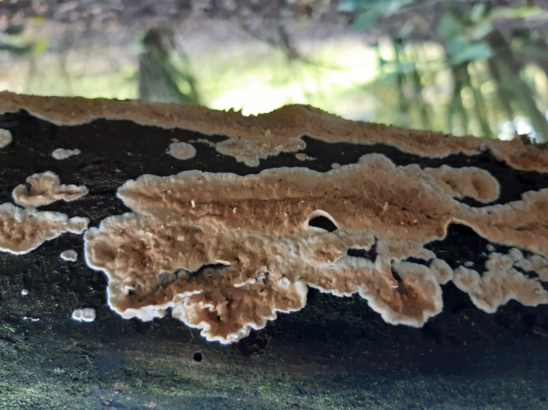 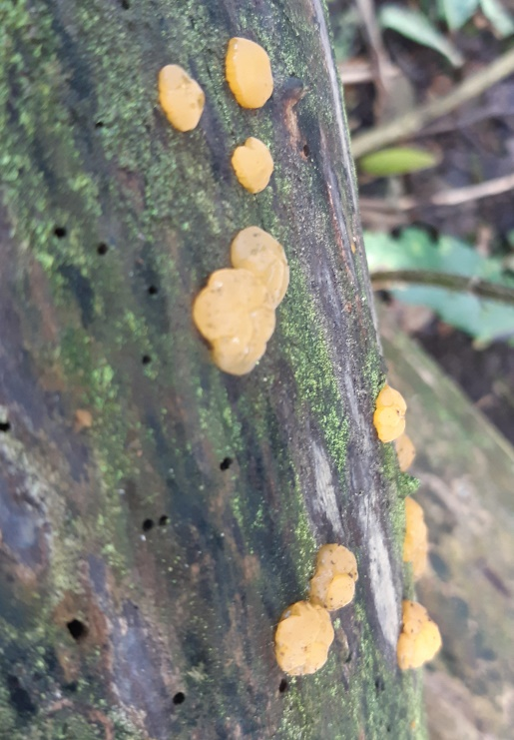

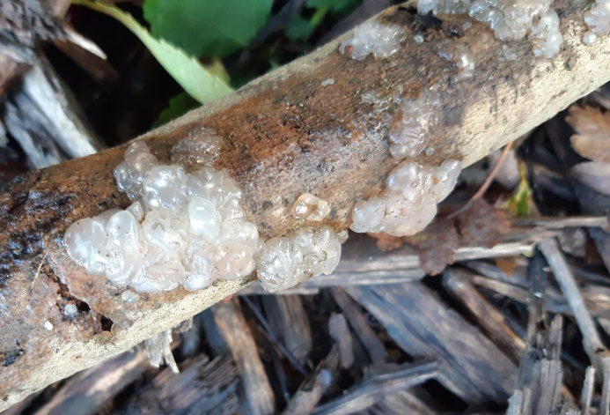 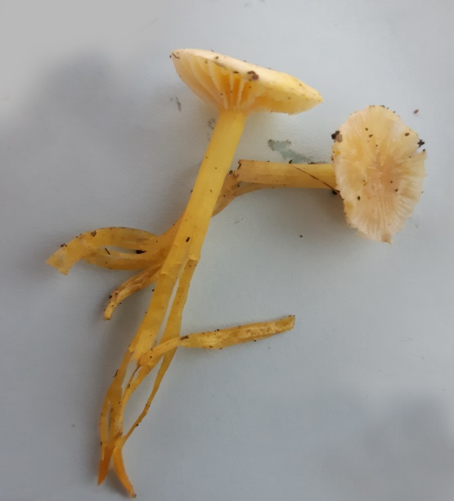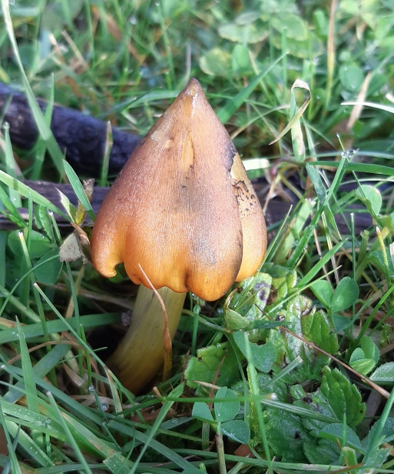 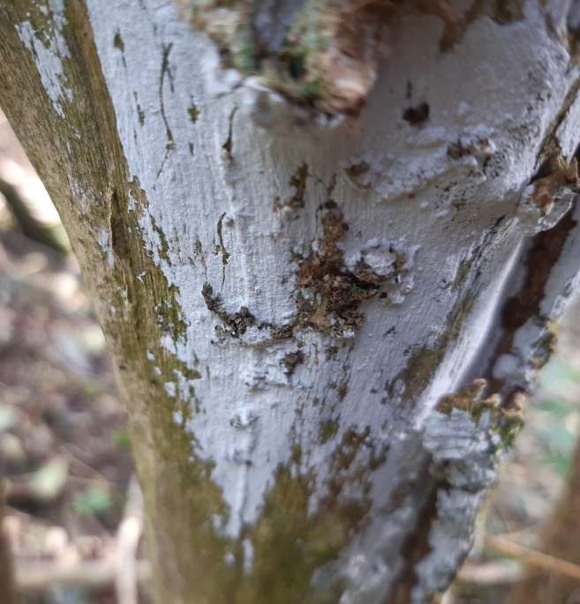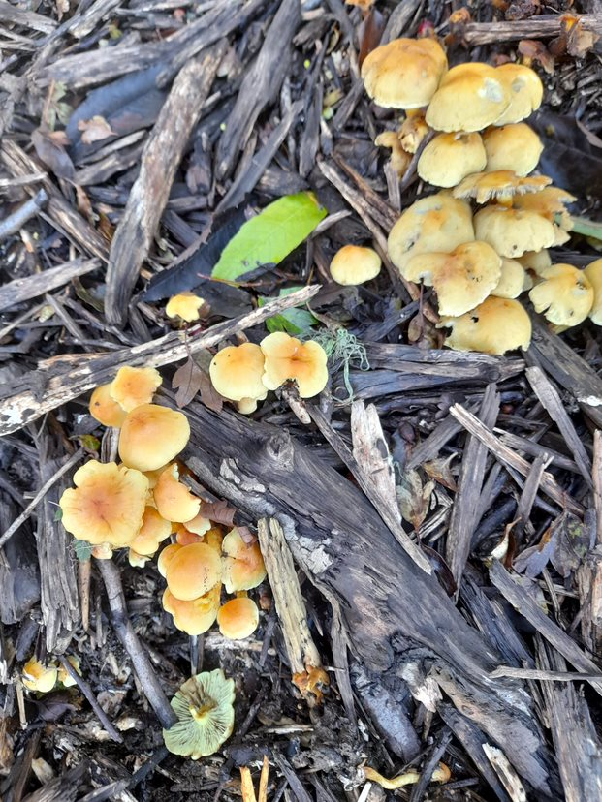 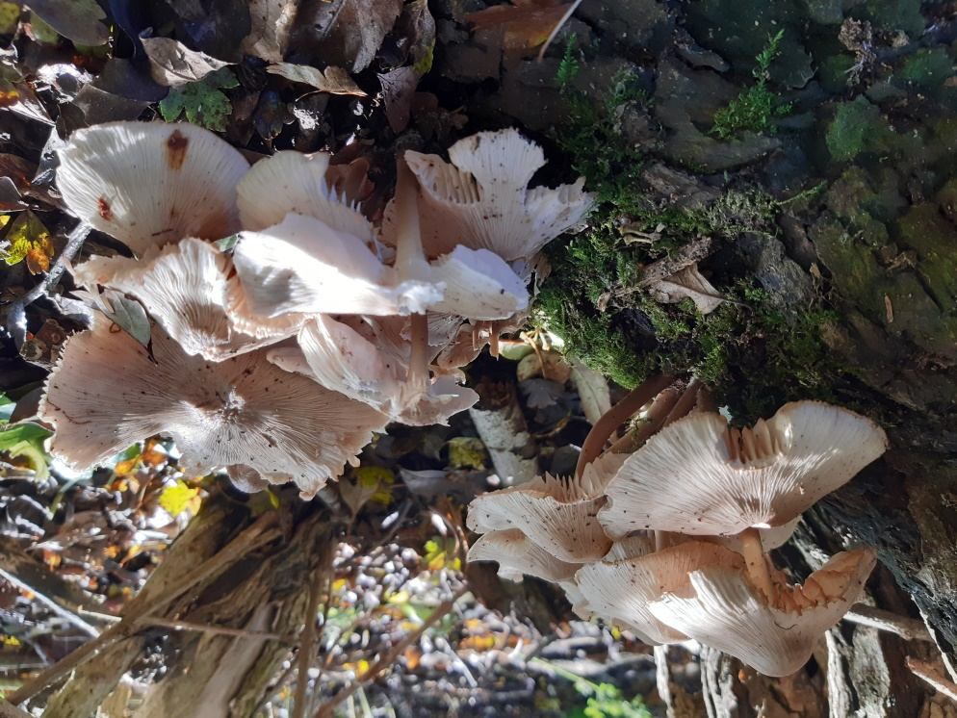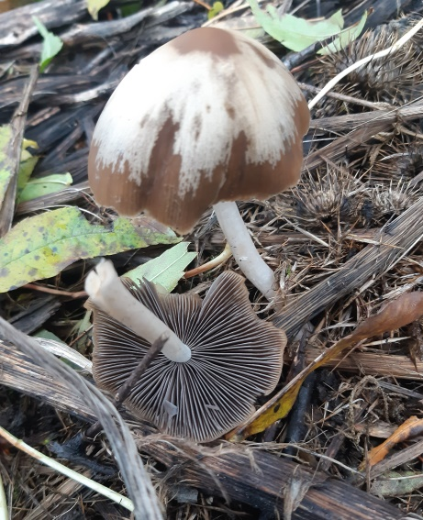 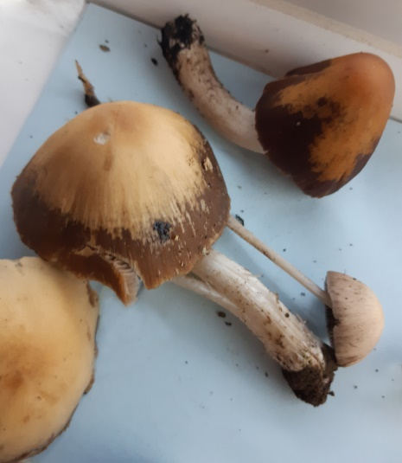 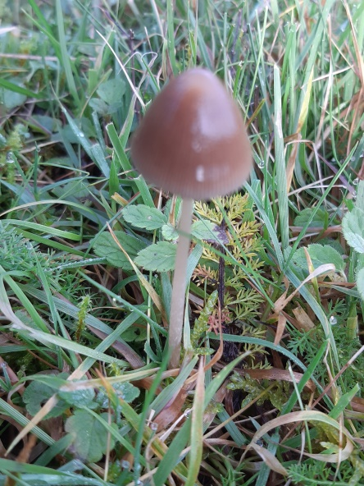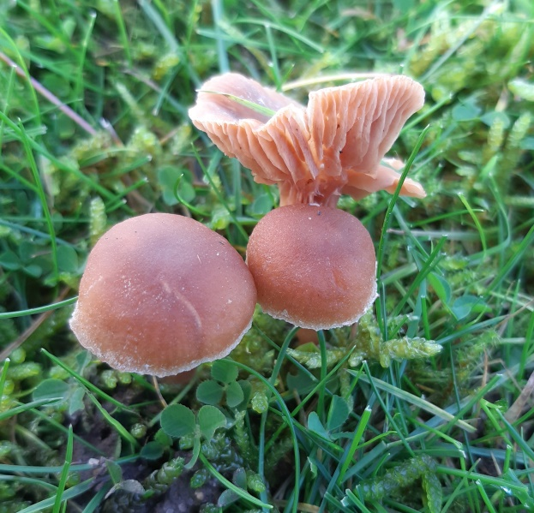 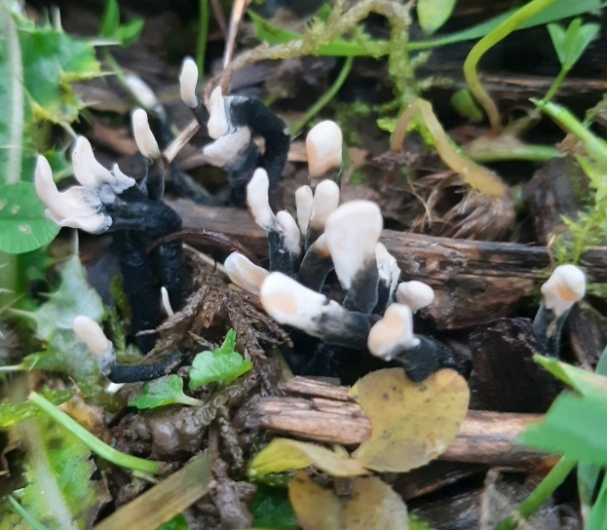

|  |  |  |  |  |  |  |  |  |  |  |
| --- | --- | --- | --- | --- | --- | --- | --- | --- | --- | --- |
| 05.11.2023 | F3 | F4 | F5 | G3 | G4 | G5 | H4 | H5 | *habitat* | *frequency* |
| *Cylindrobasidium laeve* |  |  |  |  |  |  |  | x | on dead branch | O |
| *Dacrymyces stillatus* |  | x |  |  |  |  |  | x | on decorticated dead branch | O |
| *Exidia nucleata* |  |  |  |  |  | x |  |  | on decorticated branch on ground | O |
| *Hygrocybe ceracea* |  |  |  |  |  | x |  |  | in grass | R |
| *Hygrocybe coccinea* |  |  |  |  | x |  |  |  | in grass | R |
| *Hygrocybe conica* |  |  |  |  | x |  |  |  | in grass | R |
| *Hyphodontia sambuci* |  | x |  |  |  |  |  | x | on dead hawthorn and elder | O |
| *Hypholoma fasciculare* |  |  |  |  | x | x |  | x | on buried dead wood | F |
| *Mycena galericulata* |  | x |  |  |  |  |  |  | on base of tree | R |
| *Psathyrella cf candolleana* |  |  |  |  | x | x |  |  | among wood chips | F |
| *Parasola conopilea = Psathyrella conopilus* | x | x | x | x | x | x | x | x | on wood chips, litter and woody debris | A |
| *Tubaria furfuracea* |  |  |  |  |  | x |  | x | on twigs and woody debris on ground | F |
| *Xylaria hypoxylon* |  |  |  |  |  | x |  |  | on woody debris | O |

Table copied in from Excel. The frequency column uses the DAFOR system to show how common the plant is in the squares surveyed:

Dominant

Abundant

Frequent

Occasional

Rare

We found thirteen species that we could definitely identify. It doesn’t sound much but considering the time of year and compared with other parts of Hell Wath which have very few species it’s not a bad haul. There were just two Agarics and perhaps a couple of other species that were too dried up to produce a spore print that I had to leave out otherwise I think we found all that was growing there at this time of year.

Cutting the scrub back and chipping the brash has provided a unique new habitat for those fungi that grow on woody debris *like Xylaria, Tubaria, Psathyrella, Parasola* and *Hypholoma* which were by far the most frequent. We only found three true grassland fungi, the three waxcaps, all of which were rare, just one clump of each.

The other main habitat was the dead branches in the copses and hedges around the field which provided habitat for the slime, jelly and crust fungi.

I’ve included one photo for each species that we took in the field. There is no photo of *Hygrocybe coccinea* (Scarlet Waxcap) because we didn’t see that on the day. Nobody sent in a picture of *Hygrocybe ceracea* (Butter Waxcap) so I took one of a specimen I brought home. I’ve reduced the quality to fit them into a Word File without making the file too big.

The Psathyrellas are very confusing because they are so variable. They start off like a button, then a cone, then flat and then like a funnel and they change colour from brown to mottled to white. Of the hundreds we saw, I could only be sure that we saw two species and one has had its name changed from *Psathyrella* to *Parasola*! In the middle row of the second page of photos the one on the right is *Parasola conopilea* and the one in the middle I took at home is *Psathyrella candolleana* but the one on the left could be either, I can’t be sure.

Can you match the names to the other photos? I used botanical names because many of the fungi don’t really have English common names and they often differ. For example *Hygrocybe conica* is sometimes called Blackening Waxcap -

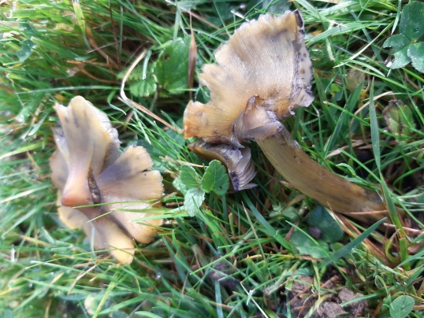

because it blackens as it gets older – and sometimes it is called Conical Waxcap because its’s conical when it’s young!.

If you type in the botanical name of each species that we found into Google and then in the suggestions look for First Nature or Nature Spot either of these will take you straight to a really good page with pictures and info for each one.

If you’ve taken any photos of species that you think I’ve not included, or better pictures of any of these, please do send them in.